National Textile University, Faisalabad

Department of Computer Science

Name: | Abdul Hannan, Massad Syed, Arslan Ali
Class: | BSCS ‘A’
Registration No: | 23-NTU-CS-1002,1048,1019
Project Report: | Documentation
Course Name: | Embedded IOT FALL -2025
Submitted To: | Sir Nasir Sb
Submission Date: | 4 January 2026

Smart Allergy and Air-Response System (SAARS)
Abstract:
This project presents the Smart Allergy and Air-Response System (SAARS), an IoT-based solution designed to mitigate respiratory health risks by monitoring indoor air quality in real-time. By integrating an ESP32 microcontroller with a suite of sensors including the MQ-135, DHT22, and PM2.5 Dust Sensor, the system detects harmful pollutants, high humidity, and particulate matter. Utilizing the Blynk Cloud platform, SAARS provides users with remote data visualization and instant mobile notifications. The system features an automated response mechanism that activates a ventilation fan via a relay whenever air quality exceeds safety thresholds, offering a low-cost, scalable approach to preventive healthcare.

Problem Statement & Objective:
Airborne allergies and respiratory issues are increasing due to poor indoor air quality and lack of real-time monitoring. Existing systems are either expensive or reactive rather than preventive.
Objectives:
• Monitor air quality parameters in real time
• Detect allergy-triggering conditions early
• Provide automatic environmental response
• Notify users remotely using IoT
• Store and visualize data for analysis
Hardware Description:
Component | Pin Type | ESP32 Pin | Function
MQ-135 Sensor | Analog | GPIO 34 (ADC1) | Measuring Air Quality Index (AQI)
DHT22 Sensor | Digital | GPIO 4 | Measuring Temperature & Humidity
PM2.5 Dust Sensor | Analog/PWM | GPIO 35 | Measuring Particulate Matter
OLED Display | I2C (SDA) | GPIO 21 | Data Visualization
OLED Display | I2C (SCL) | GPIO 22 | Clock Signal for Display
Relay Module | Digital | GPIO 5 | Controlling Exhaust Fan
Buzzer | Digital | GPIO 18 | Local Audible Alert

Software Description:
The system's software ecosystem is designed for high-speed data processing and dual-path cloud communication. The Arduino IDE was utilized for firmware development using Embedded C++, incorporating libraries for sensor interfacing and secure network protocols.
- Blynk IoT Platform: Acts as the primary Graphical User Interface (GUI), providing real-time data visualization through gauges and charts, as well as handling instant mobile push notifications.
- Firebase Real-time Database: A NoSQL cloud database used to provide permanent data persistence. It logs historical data for temperature, humidity, and PM2.5 levels, allowing for long-term air quality analysis.
- Communication Protocols: The system utilizes HTTP/SSL for secure Firebase updates and the Blynk Protocol for low-latency hardware control.

Block Diagram:
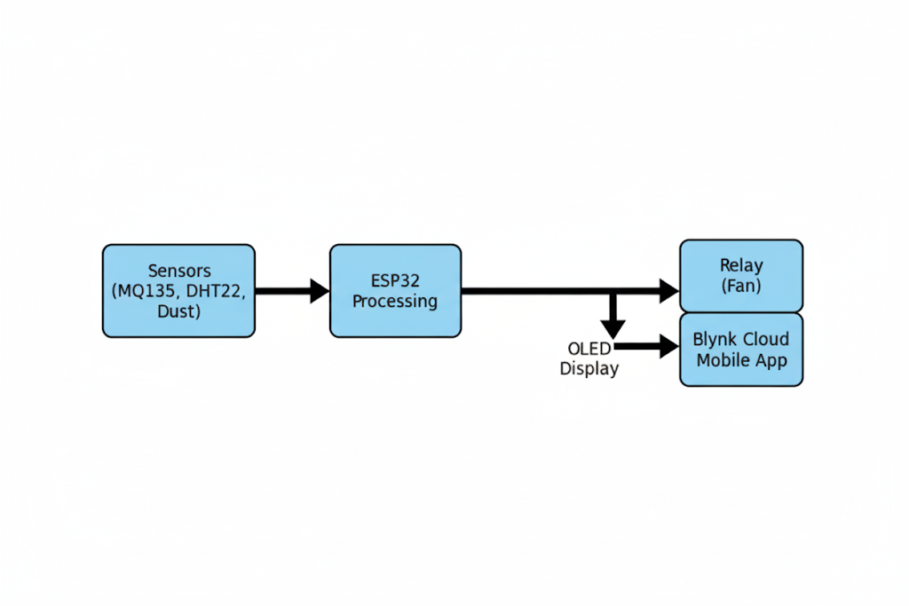
System Architecture:
The SAARS architecture follows a multi-tier IoT model to ensure reliability and scalability:
Perception Layer: Includes the MQ-135, DHT22, and PM2.5 sensors that capture raw environmental data.
Processing Layer: The ESP32 Microcontroller digitizes sensor signals and executes the threshold logic.
Connectivity Layer: The ESP32 acts as a gateway, simultaneously pushing data to the Blynk Cloud for monitoring and the Firebase Database for storage.
Application Layer: Users interact with the system via the Blynk Mobile App to view real-time statistics and receive emergency alerts.
Implementation Details:
The hardware is interfaced with the ESP32 using a combination of Analog (ADC) pins for the MQ-135 and Digital (GPIO) pins for the DHT22 and Relay module. The firmware is programmed to sample data every 2 seconds.
- Dual-Cloud Integration: The code utilizes unique Authentication Tokens for Blynk and Database Secrets for Firebase to ensure secure data transmission.
- Automation Logic: A "Smart-Response" algorithm compares the sensor values against predefined safety limits. If the PM2.5 or Gas levels exceed the threshold, the ESP32 triggers a high signal to the Relay Module, activating the exhaust fan and sounding the local buzzer.
- Local Visualization: An I2C-based OLED display provides an immediate local readout of all parameters, ensuring the system is functional even without an internet connection.
Flow Chart:
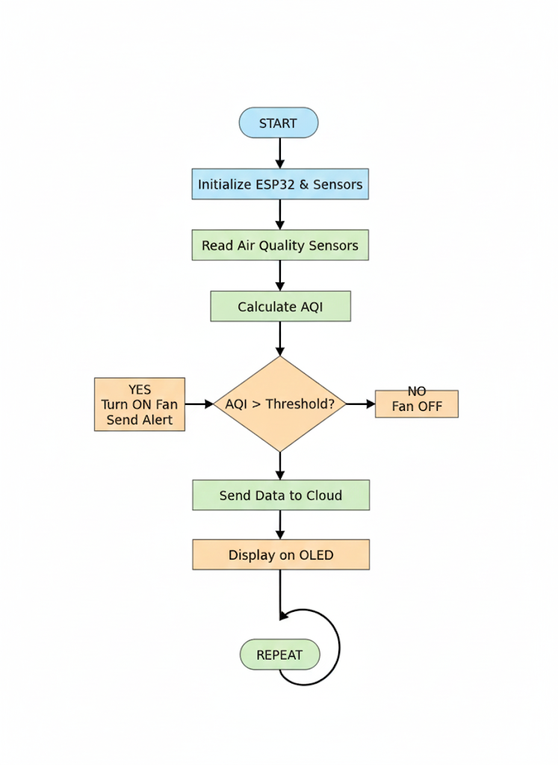

Testing & Results:
Scenario A (Baseline): The system was placed in a ventilated room. AQI remained below the threshold, the fan remained OFF, and the OLED displayed "Air Quality: Good".
Scenario B (Pollutant Detection): Upon introducing smoke near the MQ-135 sensor, the AQI calculation spiked above the predefined threshold.
Response: The Relay immediately activated the Exhaust Fan, the Buzzer sounded, and a notification was pushed to the Blynk Mobile App.

Result With Screenshots:
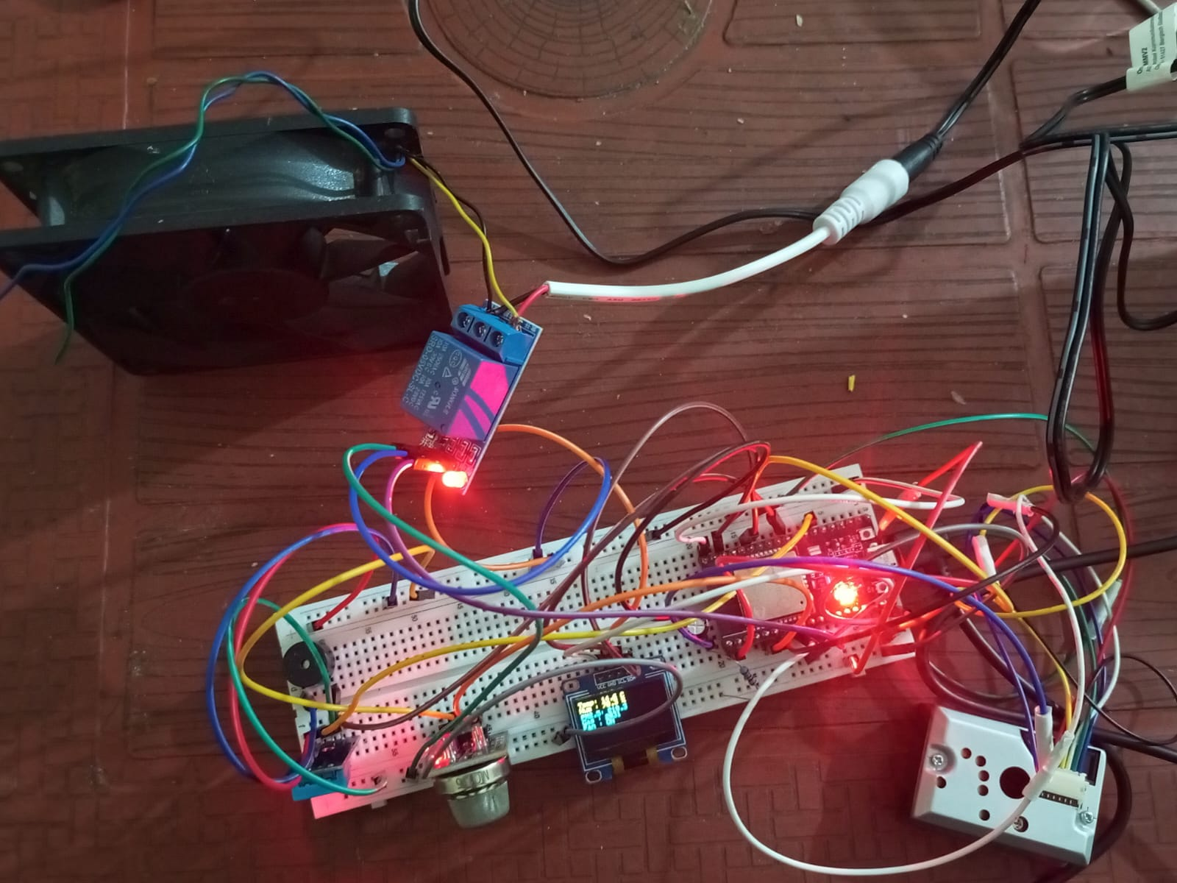
Conclusion & Future Scope:
Conclusion: The SAARS project successfully demonstrates a proactive approach to allergy management through IoT. By integrating Firebase for data logging and Blynk for real-time alerts, the system provides a robust solution for indoor air monitoring. The automated response of the exhaust fan proves the system's capability to act as a reactive safety measure.
Future Scope: While the current prototype is fully functional, its capabilities can be expanded in several ways:
- AI-Based Predictive Analytics: Integrating machine learning models (like Random Forest or ANN) to predict "Allergy Risk Days" based on historical humidity and particulate trends.
- Solar Power Integration: Implementing a solar-based charging system with deep-sleep modes to make the device energy-autonomous for outdoor or remote placement.
- Mobile App Expansion: Adding a dedicated "Health Log" feature in the app where users can correlate their symptoms with recorded air quality spikes.
- Scalable Mesh Networking: Developing a multi-node network (using ESP-NOW) where multiple sensors across different rooms communicate with a single central hub to manage an entire building's ventilation.
- Advanced Calibration: Utilizing reference-grade sensors and automated auto-calibration algorithms to reduce "sensor drift" over long-term use.
____________________________________________________

